Hospitality Management Association
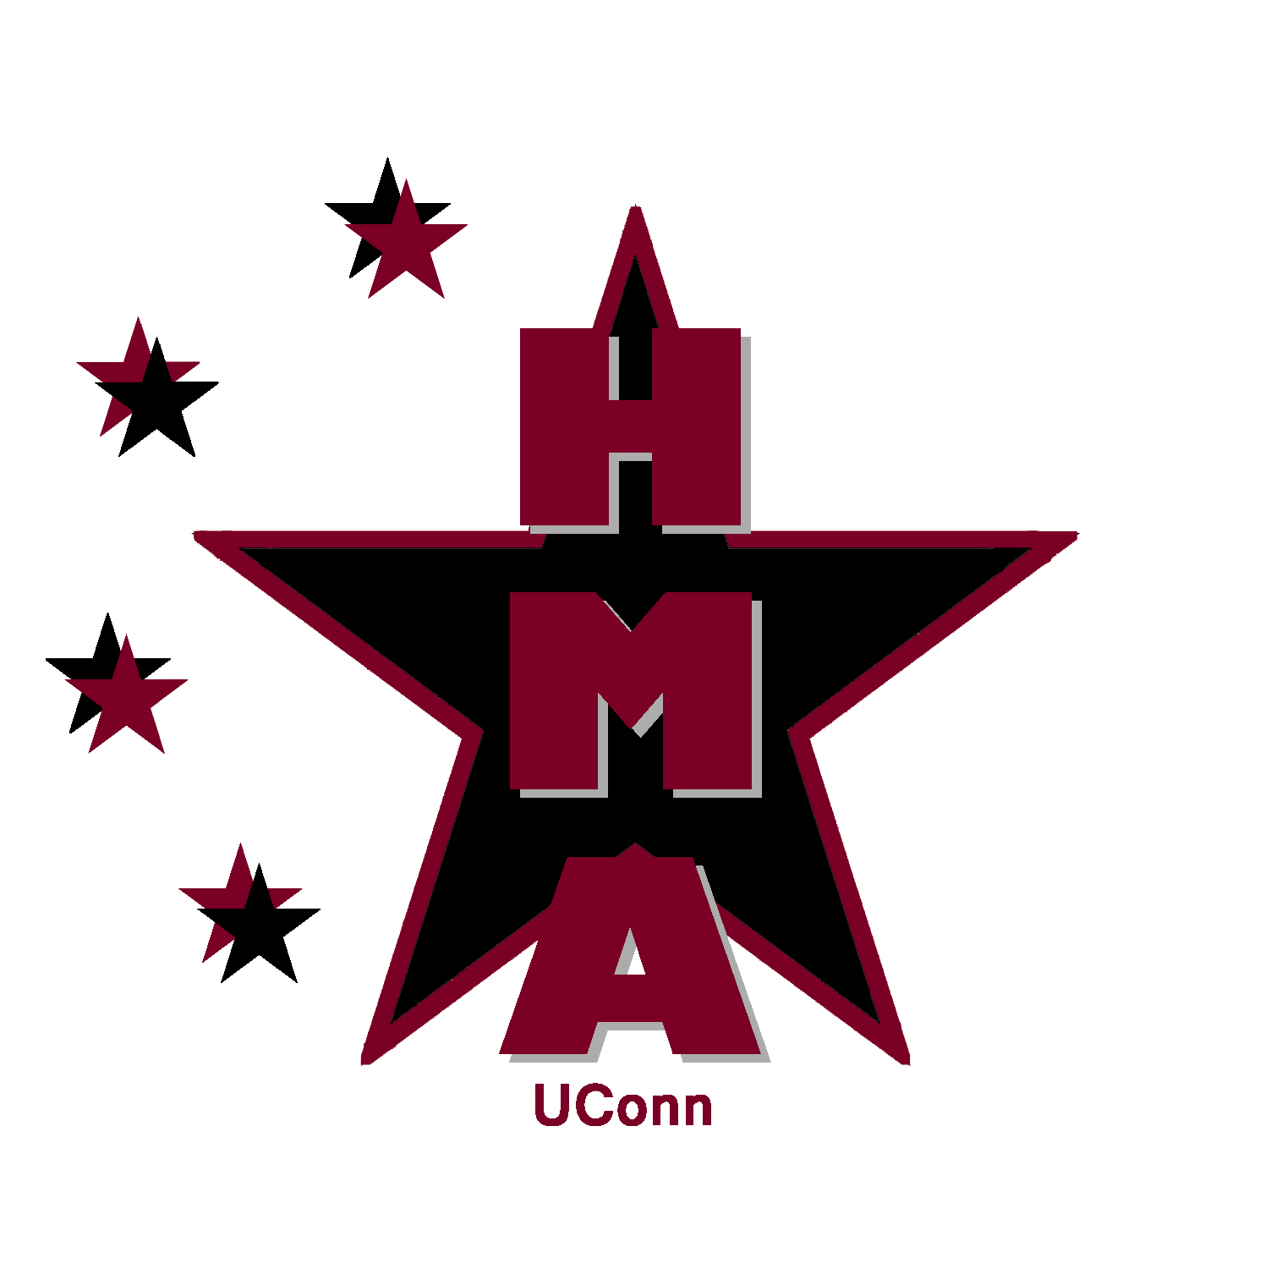
Agenda

09.05.2011
Phillips Communication Sciences Building
Second floor conference room
6pm

HMA's website
- www.business.uconn.edu/users/hma
  - Gao is putting together
- Give him your bio and photo if you haven't yet done so for the E-board page
- Amanda is putting together resources for the resources page. If you find any, send them to her.
- Who is maintaining the Events Page?

HMA's Online Calendar
- http://web2.uconn.edu/wdlcalendar/index.php/week/2011-09-03/All/All/Hospitality_Management_Association1/
  - Kate Byrne is administrator and approves event submissions
  - when submitting a posting, select "Hospitality Management Association" for calendar.
- Can also select up to 5 additional calendars on campus to have our posting added to. Recommend for further advertising.
- Also, be sure to check the box under it to add to University Main Calendar. This will add it to the university wide calendar and may feature our event on the main events site and on the front page of the Daily Campus under event listings. Great for advertising to entire campus!
- Everyone should bookmark the HMA calendar url so you can see upcoming HMA events at any time.
- Will use calendar link on our Facebook group page.

Facebook Group Page
- We have a Facebook page, but need to create a “group” page so future events can be sent out as messages.
- Who will own the page?
- Links to calendar, website

HMA's email
- uconnhma@gmail.com
- who is checking and replying to the email?
- who adds any new members to contact list, from email inquiries and sign up sheets at fairs/meetings?
- we need to send an email welcoming the new freshmen who put their name in during the orientation raffle and let them know someone has been selected to win the free membership, so they don't still wait and wonder (see next section).
- we need to send an email to the entire contact list letting them know of the first meeting on Sept 12th (not everyone on it will be at the involvement fairs)

Membership
- we need to select a new member who wins the free membership raffle from orientation (at e-board meeting?) and send email notification to that person to let them know they won.
- benefits of being a paying member vs non-paying member are on HMA's website under the Member page.
- Karolina or Jeffrey should collect member dues at meetings/events/etc and keep track of who has paid.
- Dues: $15 for the year, $10 for the semester.

Materials and requesting funds
- Karolina should request funds from Student Activities for materials HMA needs. Jeffrey can assist as well.
- any marketing materials Ailish needs
  - need to make a trifold poster to use during fairs
- nametags for all e-board members
- refreshments for first meeting if you want it

School of Business (SB) involvement Fair
- Tuesday at 2-5pm SB Courtyard, or Cafe in event of weather
- Confirm schedule of who is manning HMA table
- Sign up sheet
- Fliers for 1st member meeting on Monday, Sept 12th
  - Ailish is making
  - location is being determined, maybe BUSN 227
  - should be posted around business school on bulletin boards in entryway on 1st floor and in hallway on 2nd floor
  - Should be posted in School of Business newsletter, send to: undergrad@business.uconn.edu before 2pm Wednesday for publication Thursday.

University Involvement Fair
- Wednesday from 2-7pm in Fieldhouse, Table #35
- confirm schedule of who is manning HMA table
  - someone needs to fill in for Khoi from 3:30-4pm.
- Greg Dionne is contact person for it with Student Activities
- Sign up sheet
- Fliers
  - Ailish is making
  - location is being determined, maybe BUSN 227

First member meeting
- Monday, September 12th from 6-7pm
- Room is being determined, maybe BUSN 227
- Agenda – who is putting together agendas and taking minutes for meetings? New Director of Administration (Secretary)
  - Will agenda be emailed to members? When and by who?
  - Will minutes be emailed to members? When and by who?
  - Will they be posted in HMA’s gmail as googledoc?
  - Will they be posted to website? Whoever makes them, send to Gao when finished. He can create link to open document.
  - Gao – can you create a Meeting Minutes page on website and in it put links to documents as they become available?

Contacting Guest Speakers
- Has anyone successfully contacted a guest speaker to start planning events?
- Nathan Hale Inn contact. He agreed to do something, need to be in contact with him or colleague there. Maybe first event can be tour of facilities followed by a short talk by him or colleague.
- Potential trips/visits?
- Should get something in next couple weeks.

